**ARRAYS IN JAVA**

**Java Array Facts**

* Arrays are objects in Java.
* Size can be specified by ***int*** or ***short***, not ***long***.
* Array size **can’t** be redefined.
* ***java.io.Serializable*** supports random access of array elements.
* **Objects** are stored in **heap** segments.
* Arrays can be passed into method parameters.

**Array Declaration**



**Accessing Through For Loop**

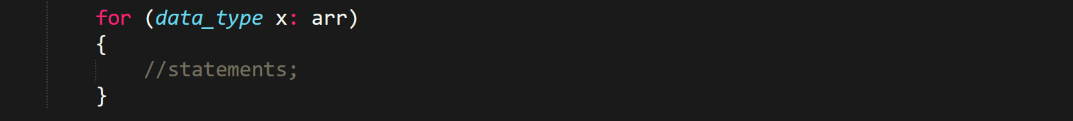

* In Java also, single line in a block **doesn’t** require curly braces.
* **JVM throws this *ArrayIndexOutOfBoundsException* when out of range.**

**Multidimensional Arrays**



**Some Methods**



* Above 2 codes prints **[Ljava.lang.Object** (first [ then first letter of array data type, then the main statement, long here).

**More Facts**

* ***clone()*** method of any class is never inherited.
* For 1D arrays, ***“deep copy”*** is done (creation of separate array containing copy).
* Similarly, **clone of multidimensional array** is known as ***“shallow copy”***.